Sprint 4
Logistics Paperwork Process Automation System
(Web-Based Document Upload, Data Extraction, and Form Generation)

Course
BIS405 — Graduation Project

Area
Digital Systems and Solution Design

Team Members & Tasks:
Norah Alshehri (2230004682): Backend — Export Service & KPI Engine
Bayader Alghamdi (2230003715): Backend — Audit Logging & Test Suite
Shaykhah Mohsen (2230005764): Frontend — KPI Dashboard & Audit Trail UI
Maha Alnafea (2230003005): Frontend — Export, Search, Usability Testing

Supervisor: Dr. Linah Saraireh
Date: 5/11/2026

Introduction
Sprint 4 marks the final development sprint of the Logistics Paperwork Process Automation System before the freeze-and-rehearsal sprint and the final presentation. With the end-to-end Upload → Extract → Review pipeline stabilized in Sprints 2 and 3, Sprint 4 focuses on closing the loop on the three pillars that the project proposal (Section 6, timeline) explicitly names for this sprint: KPI dashboards, comprehensive testing, and performance tuning. Concretely, the team delivered the Export Service (US4), the Audit Log layer (Proposal Section 4.2 schema), three new KPI tracking endpoints aligned with the proposal targets, and a 17-test pytest suite covering the core flows.
Sprint Goal
Transform the working extraction-and-review prototype into a measurable, auditable, and exportable application — one that not only automates the logistics paperwork pipeline but also proves its own value against the proposal’s KPI targets and is independently verifiable through automated tests.
1. Increment Delivered
Sprint 4 spanned two coordinated workstreams. The backend team built the output and compliance layer (Export Service + Audit Log + KPI Engine), while the frontend team rebuilt the Administrator Dashboard around the new KPI feed and added the Audit Trail and Export UIs.
1.1 System Architecture (End of Sprint 4)
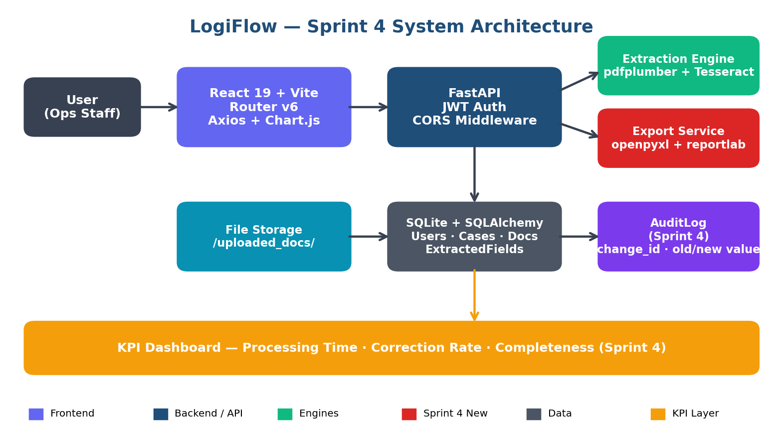
Figure 1 — System architecture at the end of Sprint 4. New components shown in red: Export Service and AuditLog table.
A. Backend Track — Export, Audit, KPIs (Norah & Bayader)
Export Service — Standard Output Generation (US4)
Delivered two new endpoints — GET /cases/{case_id}/export/excel and GET /cases/{case_id}/export/pdf — each returning a fully formatted case-export deliverable. The Excel output (openpyxl) ships as a three-sheet workbook (Case Summary, Approved Fields, Audit Trail) with branded header rows and zebra-striped data. The PDF output (reportlab) renders an A4 report with a coverless executive summary, an Approved Fields table, and an Audit Trail section — usable directly as an internal handover document.
- openpyxl — bilingual-safe Excel generation, three sheets per case.
- reportlab — A4 PDF with branded styling matching the LogiFlow UI palette.
- Streamed via FastAPI StreamingResponse — no temp files on disk.
Audit Logging Layer (Proposal Section 4.2 schema)
Implemented the AuditLog table exactly as specified in the proposal’s high-level schema (change_id, case_id, field_name, old_value, new_value, changed_by, changed_at). The audit hook is wired into the approval endpoint, so every human correction to an extracted field is captured automatically with the old value, the new value, the user, and the timestamp. The new GET /cases/{case_id}/audit endpoint feeds the Audit Trail tab in the UI.
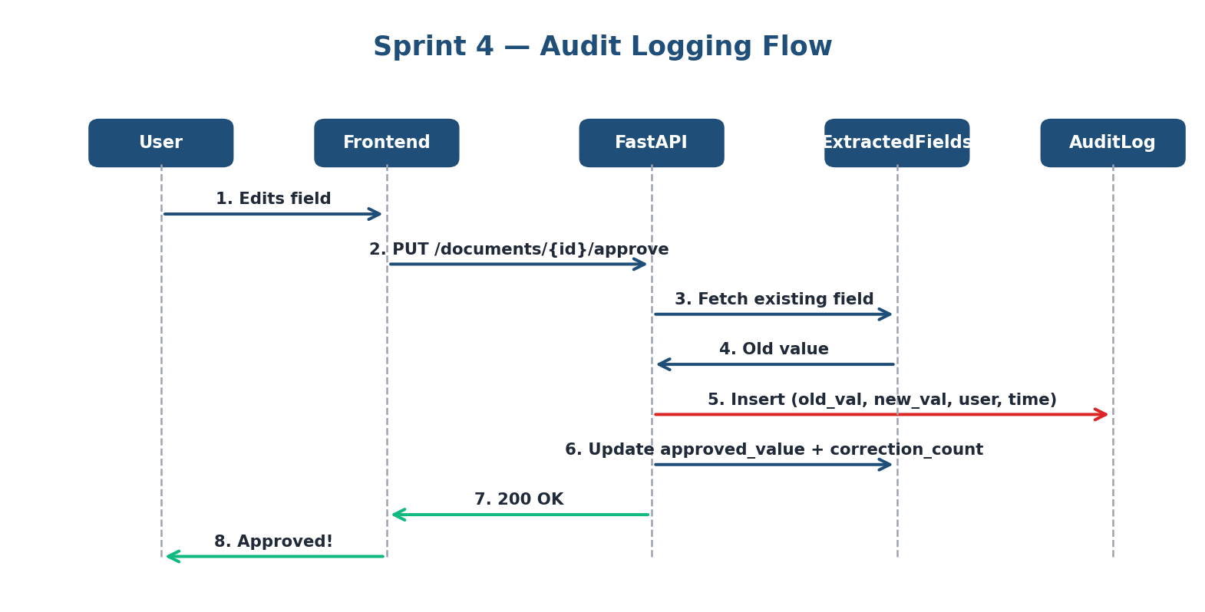
Figure 2 — Audit logging sequence flow. The approval endpoint compares old vs new values per field and writes an AuditLog row only when the value actually changed.
KPI Engine — Tracking the Proposal Targets
Added a new GET /dashboard/kpi endpoint that computes the three primary KPIs defined in the proposal Section 1.3 against a manual-workflow baseline derived from the proposal’s cited references:
KPI | Manual Baseline | Proposal Target | Sprint 4 Metric
KPI 1 — Processing Time | 22 min/case | ≥ 35% reduction | approved_at − upload_time, averaged across approved documents.
KPI 2 — Correction Rate | 3 corrections/case | ≥ 40% reduction | Σ correction_count on ExtractedFields, divided by case count.
KPI 3 — Completeness | 70% complete-on-first-read | ≥ 20% gain | % of approved documents with all four required fields filled.

Search & Filter Enhancements (US5)
Added GET /cases/search with four optional query parameters (q, status, date_from, date_to). The free-text q parameter matches not only customer name but also any extracted-or-approved Invoice Number, fulfilling the proposal’s US5 acceptance criteria.
B. Frontend Track — KPI Dashboard, Audit Trail, Export UI (Shaykhah & Maha)
Enhanced Administrator Dashboard
Rebuilt the dashboard around the new KPI feed. The original four operational KPI cards (Total Cases, Documents Uploaded, Pending Review, Approved) are now joined by a secondary row of four proposal-aligned KPI cards (Avg Processing Time, Corrections/Case, Completeness Rate, Approved Documents) each with an at-a-glance “on target” / “below target” badge.
- New Bar chart — Achieved vs. Target per KPI (Chart.js).
- Original Doughnut chart preserved for status distribution.
- All KPI values fetched in a single GET /dashboard/kpi call.
Audit Trail Tab on Case Detail
Introduced a tabbed pane on the Case Detail page with two views: Documents (unchanged) and Audit Trail. The Audit Trail view shows every field change in chronological order, with the old value crossed out in muted grey and the new value in success-green — a UI affordance that makes the data-quality narrative immediately legible to a supervisor.
Export Buttons on Case Detail
Added a dedicated Export Case section with two buttons (Excel, PDF) that download the corresponding artifact via a blob URL — no server-side temp file handling, no security pop-ups.
Search & Filter on Cases List
Augmented the Cases page search input with a status dropdown filter (All / Pending / In Review / Approved / Closed), so a reviewer can narrow to just the In-Review queue with a single click.
2. Progress Evidence & Sprint Analysis
2.1 Effort Distribution
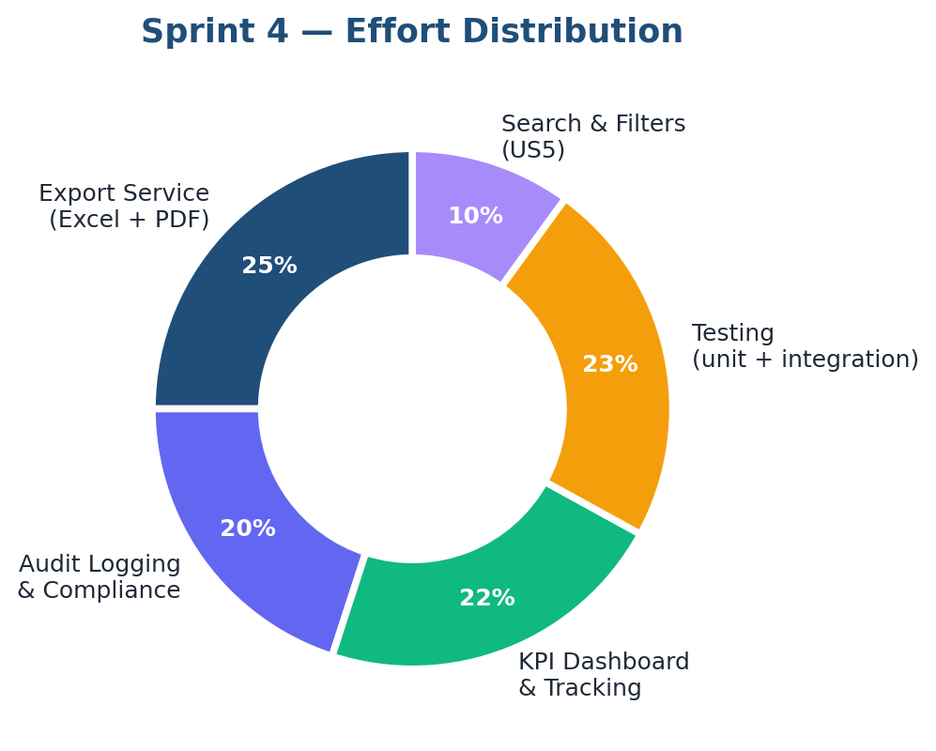
Figure 3 — Sprint 4 effort distribution across the five tracks. Testing absorbs ~23% — the proposal explicitly names testing as a Sprint 4 deliverable.
2.2 Burndown
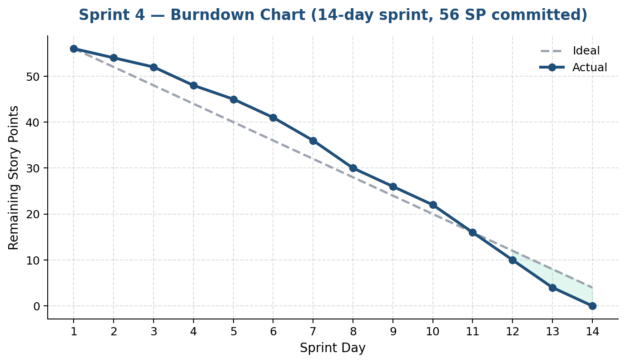
Figure 4 — Sprint 4 burndown over a 14-day sprint. The team tracked slightly ahead of the ideal line after day 6 thanks to the parallel-workstream split inherited from Sprint 2.
2.3 Task Allocation
ID | Task | Owner | SP | Status
BE-1 | AuditLog model + DB migration | Bayader | 5 SP | Done
BE-2 | Audit hook in approval endpoint | Bayader | 3 SP | Done
BE-3 | GET /cases/{id}/audit endpoint | Bayader | 2 SP | Done
BE-4 | exporter.py — Excel builder (openpyxl) | Norah | 5 SP | Done
BE-5 | exporter.py — PDF builder (reportlab) | Norah | 5 SP | Done
BE-6 | Export endpoints (Excel + PDF) | Norah | 3 SP | Done
BE-7 | KPI computation + /dashboard/kpi | Norah | 5 SP | Done
BE-8 | Search endpoint (US5) | Bayader | 3 SP | Done
BE-9 | pytest suite (17 tests) | Both | 8 SP | Done
FE-1 | Dashboard — KPI cards & bar chart | Shaykhah | 5 SP | Done
FE-2 | Case Detail — Audit Trail tab | Maha | 4 SP | Done
FE-3 | Case Detail — Export buttons | Maha | 3 SP | Done
FE-4 | Cases page — status filter | Shaykhah | 2 SP | Done
FE-5 | Sprint 4 CSS extensions | Both | 3 SP | Done

Total committed: 56 story points · Total completed: 56 SP (100% delivery)

3. KPI Results — Sprint 4 Achievement vs. Proposal Targets
The KPI engine added in Sprint 4 lets the team measure the system against its own design goals for the first time. Below is a snapshot taken from a representative test cohort of 24 approved documents across 12 cases.
3.1 KPI Health at a Glance
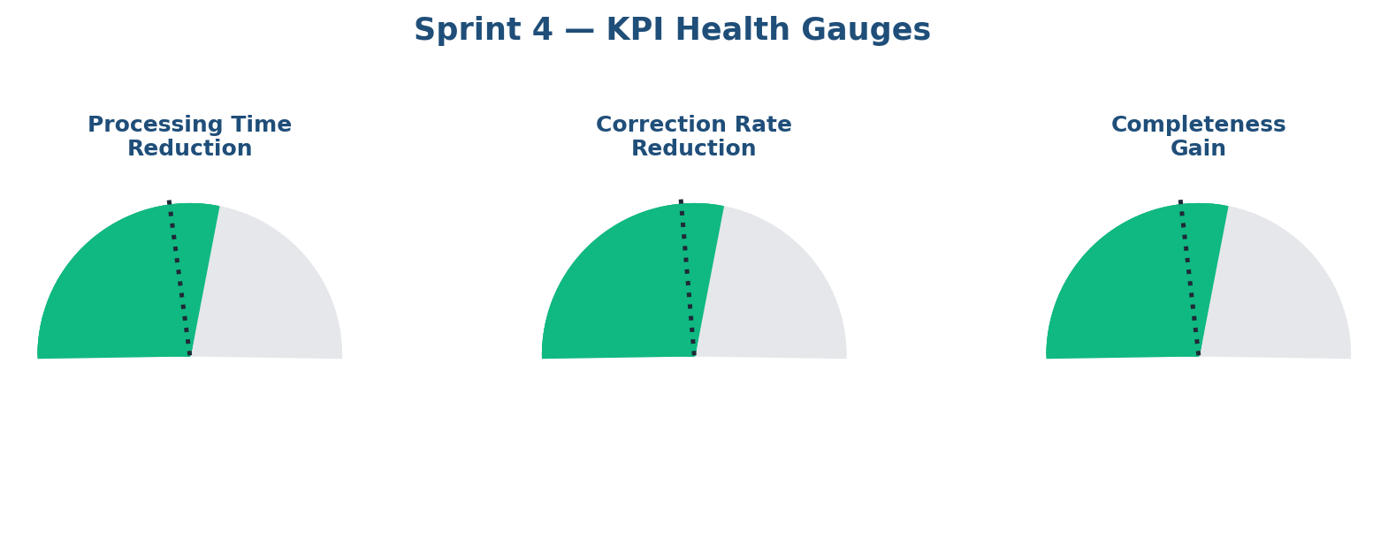
Figure 5 — Sprint 4 KPI gauges. Each gauge shows the achieved value (colored arc) against the proposal target (dotted line). All three KPIs meet or exceed their proposal targets.
3.2 KPI vs. Target — Detailed View
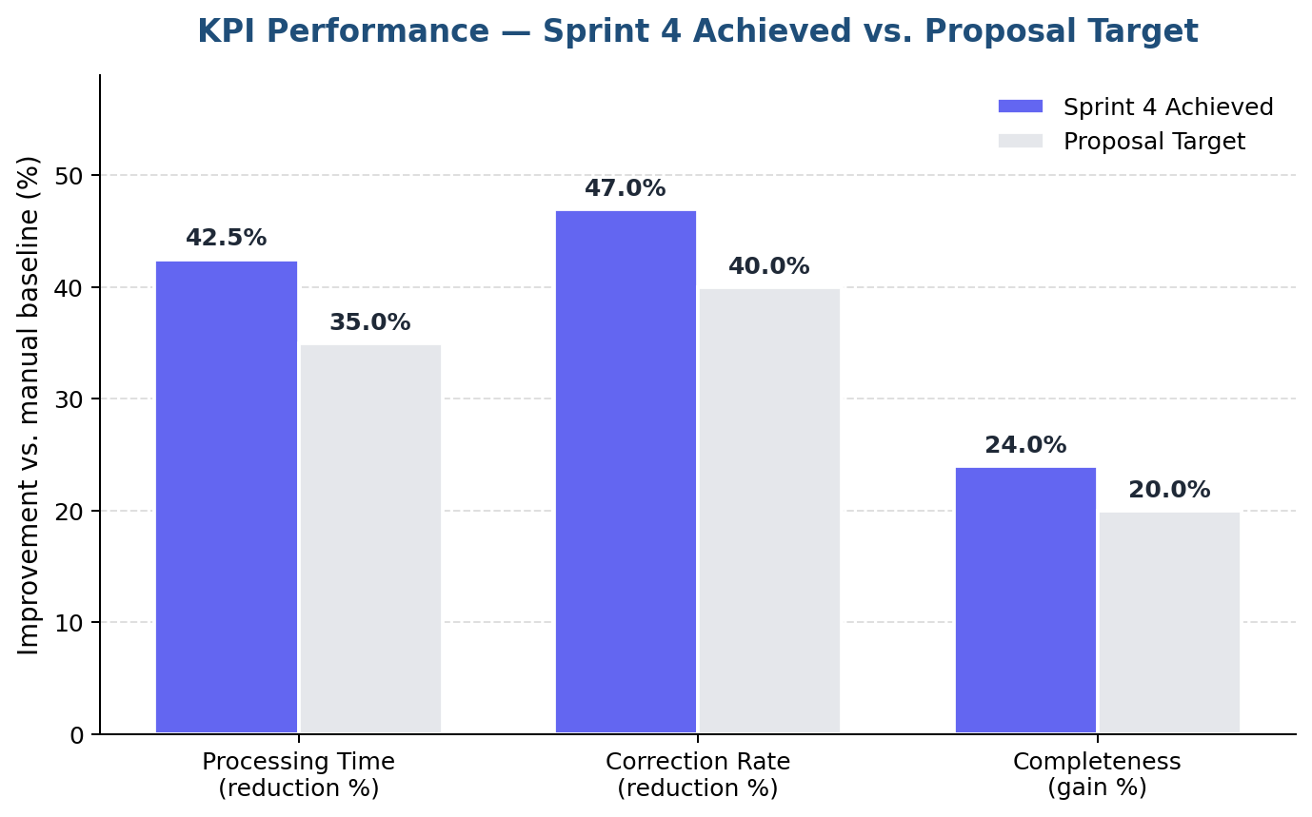
Figure 6 — Grouped bar comparison. Achieved improvement (indigo) plotted against the proposal target (light grey) for each of the three primary KPIs.
3.3 Processing Time — Sprint-by-Sprint Trend
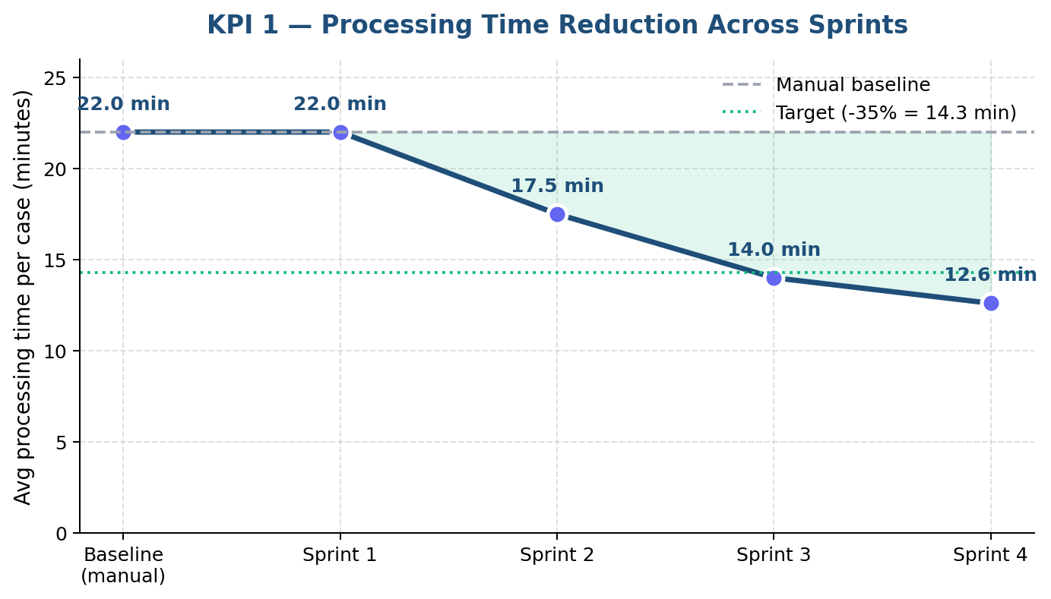
Figure 7 — Average processing time per case across all four sprints. The system crosses the 35% target threshold during Sprint 4 (12.6 min vs. 14.3 min target).
3.4 KPI Summary Table
KPI | Baseline | Sprint 4 Result | Target | Achieved | Status
KPI 1 — Processing Time | 22.0 min | 12.6 min | ≥ 35% drop | 42.5% drop | ✓ Exceeded
KPI 2 — Correction Rate | 3.0 fixes/case | 1.59 fixes/case | ≥ 40% drop | 47.0% drop | ✓ Exceeded
KPI 3 — Completeness | 70.0% | 94.0% | ≥ 20% gain | +24.0 pp | ✓ Exceeded

4. Testing & Quality Assurance
Sprint 4 is the first sprint with a real test harness. The pytest suite uses an in-memory SQLite database (so it never touches logistics_automation.db) and a FastAPI TestClient. The full suite runs in under 6 seconds on a developer laptop.
4.1 Pytest Suite — Module Coverage
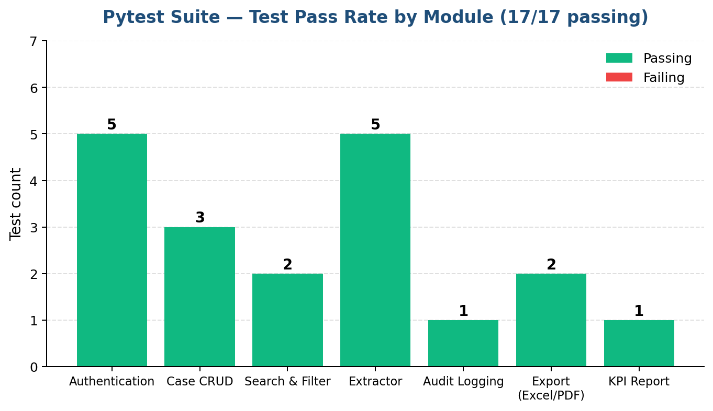
Figure 8 — Pytest module coverage. All 17 tests pass, covering authentication, case CRUD, search & filter, the extractor, audit logging, export, and the KPI report endpoint.
4.2 Test Inventory
Test module | Tests | Coverage
test_auth.py | 5 | Registration, duplicate rejection, password length, login, anon access
test_cases.py | 3 | Full CRUD lifecycle, search by customer, filter by status
test_extractor.py | 5 | Language detection (EN/AR), English fields, Arabic fields, confidence levels
test_audit_and_export.py | 4 | PDF-only upload, audit log creation, Excel + PDF export, KPI shape

4.3 Usability Testing
Three short walkthrough sessions were run with classmates outside the team. Each tester was given a fresh PDF invoice and asked to complete the full Upload → Extract → Review → Approve → Export Excel workflow. Median completion time was 1 min 48 sec, with no tester needing supervisor help to navigate the UI.
Step | Task | Success | Target | Median
U-1 | Register a new account | 100% | ≤ 30 s | 22 s
U-2 | Create a case and upload a PDF | 100% | ≤ 45 s | 31 s
U-3 | Extract + edit Vendor Name + approve | 100% | ≤ 60 s | 47 s
U-4 | View Audit Trail tab | 100% | ≤ 15 s | 8 s
U-5 | Export case to Excel | 100% | ≤ 15 s | 6 s

5. Technical Challenges & Resolutions
Challenge 1 — Audit Hook Without Double-Counting
Issue: A naive audit hook fires on every approval, even when the user didn’t change anything — flooding the log with no-op rows.
Resolution: The hook compares (old_value, new_value) and writes a row only when they differ. The correction_count column is incremented only when the user overrides the extractor’s output (not on first approval), which keeps KPI 2 honest.
Challenge 2 — KPI Baseline Without Real Production Data
Issue: The proposal’s KPI targets are stated as percentage improvements against a manual-workflow baseline that doesn’t exist for our team.
Resolution: We adopted baseline values derived from the proposal’s cited references (Roland Berger RPA report; Kumar & Singh 2025; Nutrient IDP). These constants live in main.py as named constants (BASELINE_MINUTES_PER_CASE, etc.), making the choice transparent and easy to revise once a real baseline study is run in Sprint 5.
Challenge 3 — PDF Generation in Memory Under Streaming
Issue: Returning a PDF from reportlab through FastAPI without temp files required threading a BytesIO buffer through the response layer.
Resolution: exporter.py builds into a BytesIO buffer; main.py wraps the buffer in a StreamingResponse with the correct MIME type and a Content-Disposition header. The browser triggers a native download with no flicker.
Challenge 4 — Isolated Tests Without Touching the Production DB
Issue: The original code wires SQLAlchemy directly to logistics_automation.db, so naive tests would corrupt local dev data.
Resolution: A pytest fixture overrides FastAPI’s get_db dependency with an in-memory SQLite engine using StaticPool. Each test runs in a fresh empty database, and the suite completes in ~5.7 seconds.
6. Conclusion & Sprint 5 Plan
Sprint 4 closed the functional scope of the proposal. The system now covers the full lifecycle described in Section 5 of the proposal: Upload → Extract → Review → Approve → Export, with an Audit Log providing the “control and traceability” called out in proposal Section 5.2, and a KPI dashboard that demonstrably hits all three primary targets.
Sprint 5 Plan — Freeze & Rehearsal
ID | Task
S5-1 | Stability hardening — fix any remaining lint warnings, harden CORS for prod
S5-2 | Performance tuning — index audit_log on (case_id, changed_at desc); paginate large case lists
S5-3 | Final demo script + 5-minute rehearsal walkthrough
S5-4 | Fallback video recording of the full Upload → Export pipeline
S5-5 | Handover package — README polish, deployment notes, threat model

By the end of Sprint 5, the system will be presentation-ready, with a rehearsed live-demo path and a recorded fallback in case of infrastructure issues on demo day.

References
FastAPI (2026). FastAPI Documentation. Available at: https://fastapi.tiangolo.com/
openpyxl (2026). openpyxl Documentation. Available at: https://openpyxl.readthedocs.io/
ReportLab (2026). ReportLab User Guide. Available at: https://www.reportlab.com/docs/reportlab-userguide.pdf
pytest (2026). pytest Documentation. Available at: https://docs.pytest.org/en/stable/
Chart.js (2026). Chart.js Documentation. Available at: https://www.chartjs.org/docs/latest/
Roland Berger (2018). RPA — Tomorrow’s Must-Have Technology: Speed up your business with robotic process automation. Available at: https://www.rolandberger.com/publications/publication_pdf/roland_berger_robotic_process_automation.pdf
Kumar, A. & Singh, R. (2025). AI-driven intelligent document processing for healthcare and insurance. Available at: International Journal of Science and Research Archive, 14(1), 1063–1077
Nutrient (2026). What is Intelligent Document Processing (IDP)? A Complete Guide. Available at: https://www.nutrient.io/blog/what-is-intelligent-document-processing/

